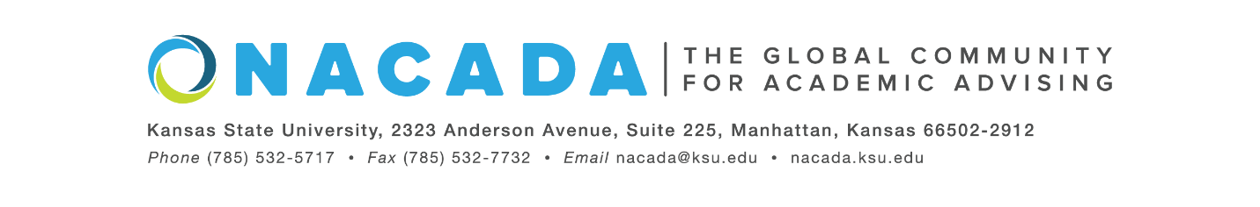
NACADA: The Global Community for Academic Advising
INSERT DATE
For Immediate Release

For more information about the Global Awards Program for Academic Advising, visit: https://www.nacada.ksu.edu/Programs/Awards/Global-Awards.aspx
Or Contact: Liz Alcantara, NACADA: The Global Community for Academic Advising
nawards@ksu.edu

INSERT NAME, of INSERT INSTITUTION, was selected for an Outstanding New Advisor Award Winner in the Faculty Advising category as part of the 2022 Global Awards Program for Academic Advising from NACADA: The Global Network for Academic Advising.
This award is presented to individuals who have demonstrated qualities associated with outstanding academic advising of students, who have served as an advisor for a period of three (3) or fewer years and whose primary responsibility is teaching. Faculty in this category make a significant impact on their students and colleagues and embody the NACADA Core Values. The award will be presented during a ceremony at the NACADA Annual Conference in Portland, Oregon this fall.
Since 1983, NACADA has honored individuals and institutions making significant contributions to the improvement of academic advising. Our goal is to promote quality academic advising and professional development of members to enhance the educational development of students.
NACADA’s membership has grown to over 14,000 faculty, professional advisors, administrators, counselors, and others in academic and student affairs concerned with the intellectual, personal, and vocational needs of students. In addition, NACADA is the representative and advocate for academic advising and for those providing that service to higher education.
-end-

